|  |
| --- |
|  |
| 新概念 3 册 |
| Lesson39 |

Lesson 39 Nothing to worry about

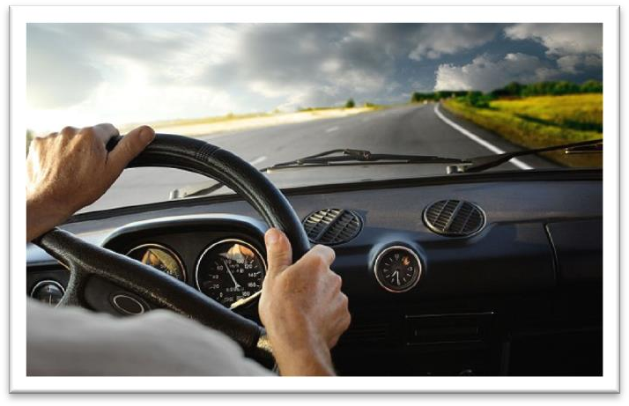

**boulder ['bəuldə(r)]**

**n. （风化的）大圆石头**

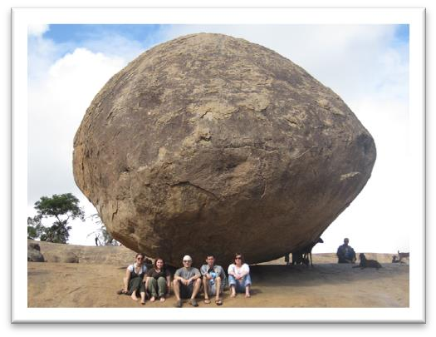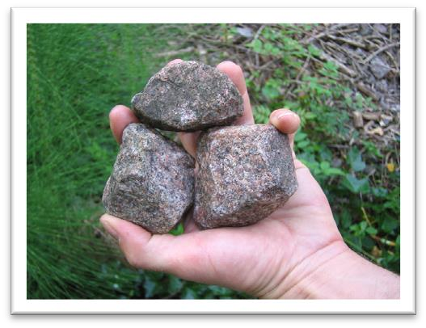boulder stone

Rock pebble

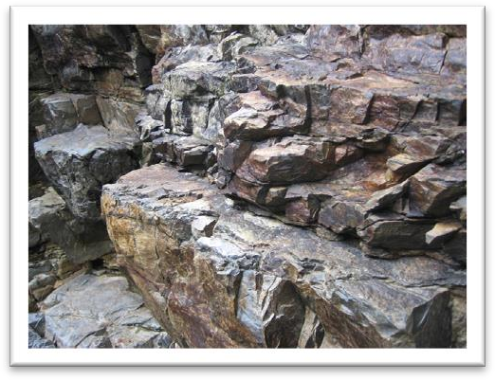 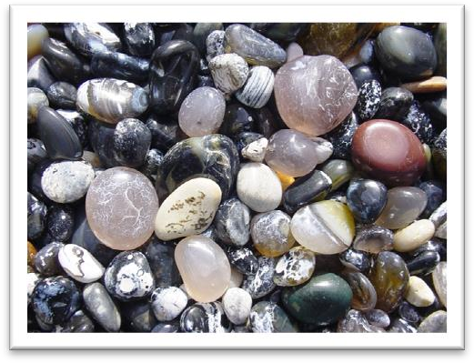

Fossil

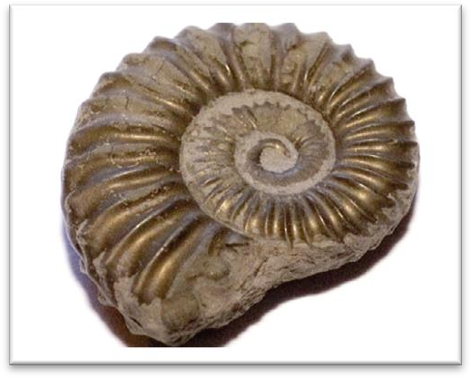

perturb [pə'tɜ:b]

**v. 使不安**

The letter shocked and disturbed / perturbed me.

It is disturbing / perturbing to think that a dangerous wild animal is still at large in the quiet countryside.

Ministers declared themselves profoundly disturbed / perturbed by the violence. “turb” = stir

disturb perturb turbine

turbid turbid water

turbulent turbulent waves

the turbulent times of the French Revolution

underestimate [ʌndər'estɪmeɪt]

**v. 低估**

Never underestimate the power of the press. overestimate 高估

He tends to overestimate his own abilities. underrate 对……评价过低

As an actor, he is seriously underrated. overrate 对……评价过高

In my opinion, she is a hugely overrated singer. understate 对……轻描淡写

It would be a mistake to understate the seriousness of the problem. overstate 对……过分夸张

He may have overstated his ability in the interview. underplay 贬低……

She underplays her achievements. overplay 过分强调……

You must not overplay his part in the negotiations.

swerve [swɜ:v]

**v. 突然转向**

swerve turn veer

As we bumped over the dusty track, we swerved to avoid large boulders.

The lorry swerved sharply to avoid the child.

He swerved suddenly, narrowly missing a cyclist.

After the alarm had been given, the great ship turned sharply to avoid a direct collision. Moments before crashing, the jet was seen veering sharply to the right.

change course

The plane changed course to avoid the storm. unswerving

unswerving loyalty / belief / support …

ominously ['ɒmɪnəslɪ] adv. 不吉利地，不祥地

I went into the kitchen and found him lying ominously still on the floor. ominous

There was an ominous silence at the other end of the phone. omen

a good / bad omen

He was convinced that seeing the black cat was a bad omen. auspicious

It was an auspicious date for a wedding.

They won their first match of the season which was an auspicious start / beginning. inauspicious

He made an inauspicious start to his career by breaking a leg in his first race.

There has long been a superstition among the Chinese that seeing a magpie is an auspicious omen.

There has long been a superstition among the Chinese that hearing the crowing of a crow is an ominous omen.

rip [rɪp]

**v. 撕破，扯破**

I ripped my jeans on the fence. The flags had been ripped in two. The nail ripped a hole in my jacket. She ripped the letter open.

Be careful with that dress; it rips easily. tear (tore torn tearing)

She realized she had torn her jacket on a nail. I tore a hole in my jeans.

He tore the letter in two. I tore open the package.

Careful, the fabric tears very easily. split (split split splitting)

One of the boxes had split open. Her dress had split along the seam.

Don't tell me you've split another pair of pants!

petrol ['petrəl]

**n. 汽油**

petrol gasoline / gas

petrol tank gas tank petrol / service station gas station

petroleum crude oil

OPEC: Organization of Petroleum Exporting Countries

obstacle ['ɒbstəkl]

**n. 障碍物**

The area was full of streams and bogs and other natural obstacles. obstacle to …

obstacles to world peace

The tax puts obstacles in the way of companies trying to develop trade overseas. block

a block in the pipe / drain block to …

The government's stubborn attitude was a block to further talks. hindrance to …

The higher interest rates have been a hindrance to economic recovery. To be honest, she was more of a hindrance than a help.

barrier

The crowd had to stand behind barriers. the language barrier

barrier to …

Lack of confidence is a psychological barrier to success. impediment

a speech impediment impediment to …

War is one of the greatest impediments to human progress.

renew [rɪ'nju:]

**v. 更新，换新；继续；延期**

renew the water in the goldfish bowl The window frames need to be renewed. We renewed our journey the next day.

I need to renew my passport this year.

renewed adj. happening again with increased interest or strength [only before noun] 更强烈的……

renewed determination / enthusiasm

Renewed fighting has been reported on the border. In response to renewed pleadings, Bruce stopped. **pleading ['pli:dɪŋ]**

n. 恳求；adj. 恳求的

pleading n. an act of asking for sth. that you want very much, in an emotional way He simply ignored my pleading.

pleading eyes

a pleading tone of voice plead

plead for …

Civil rights groups pleaded for government help. He was on his knees, pleading for forgiveness. plead with sb. to do sth.

Moira pleaded with him to stay.

She pleaded with him not to leave her alone.

plead ignorance / illness / a headache / tiredness / insanity Ellie pleaded tiredness and went to bed very early.

She stayed home from work, pleading illness.

No one can plead ignorance of a subject any longer, for there are countless do-it-yourself publications.

The rough road *across the plain* soon became so bad that we tried to get Bruce to drive back to the village we had come from.

get sb. to do

He got his sister to help him with his homework. We couldn't get him to sign the agreement. persuade sb. to do / into doing

I finally managed to persuade her to go out for a drink with me. Don't let yourself be persuaded into buying things you don't want.

In their efforts to persuade us to buy this or that product, advertisers have made a close study of human nature and have classified all our little weaknesses.

talk sb. into doing

We finally talked Father into buying the new car. get sb. not to do

persuade sb. not to do / out of doing talk sb. out of doing

dissuade sb. from doing

Even though the road was littered with boulders and pitted with holes, Bruce was not in the least perturbed.

be littered with …

The garden was soon littered with chunks of metal which had once made up a lawn mower. litter

There is always hope that in its labyrinth of musty, dark, disordered rooms a real rarity will be found amongst the piles of assorted junk that litter the floors.

be pitted with …

The road was pitted with holes. His face is pitted with smallpox. be dotted / scattered with … The sky is ~ with stars.

The lawn is ~ with pine trees.

be covered with …

Before she had anchored, the men from the boats had climbed on board and the decks were soon covered with colourful rugs from Persia, silks from India, copper coffee pots, and beautiful handmade silverware.

be loaded with …

Small boats loaded with wares sped to the great liner as she was entering the harbour. be filled with …

… it is filled with what looks like a thick, greyish substance.

All at once, I noticed that my wife seemed to be filled with alarm. be packed / crammed with …

The streets were packed / crammed with Christmas shoppers.

It has been estimated that if the bridge were packed with cars, it would still only be carrying a third of its total capacity.

be stuffed with …

a pillow stuffed with feathers

duck stuffed with ‘eight treasures’ stuffed birds

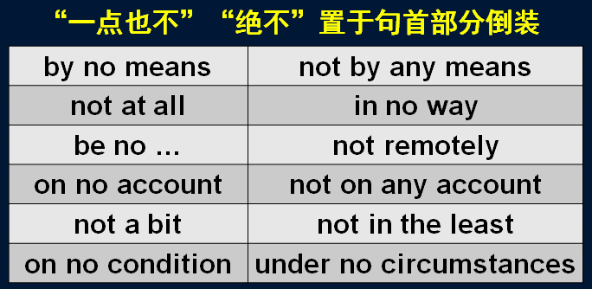I’m stuffed.=I’m full.

Though Verrazano is by no means considered to be a great explorer, his name will probably remain immortal, for on November 21st, 1964, the longest suspension bridge in the world was named after him.

She is by no means pretty.

She's not a bad kid, by any means.

By no means *can* theory be separated from practice. She's not at all happy about the current situation.

This will in no way influence our original decision. I am no expert.

That girl is no fool.

Larry is no friend of mine.

His arguments are not remotely convincing.

On no account *must* you disturb me when I'm working. Do not on any account leave the prisoner unguarded.

I tried to convince them, but they weren't in the least interested. "Was she annoyed?" "Not a bit! She was delighted."

On no condition *should* untrained personnel use the equipment. Under no circumstances *will* we agree to splitting up the company. not a little = more than a little = very

Graham was not a little / more than a little frightened by what he had seen. perturbed = disturbed = worried

Glancing at his map, he informed us *that the next village was a mere 20 miles away*. glance at …

inform sb. of / about sth. inform sb. that … convince sb. of sth.

convince sb. that … a mere … 仅仅……

a mere 后跟单数名词时 = only a / an

在其他情况下 a mere = only

Glancing at his map, he informed us that the next village was a mere (=only) 20 miles away. It went direct from my local station and the journey lasted a mere (=only an) hour and 17 minutes.

It was not that Bruce always underestimated difficulties, but (that) he simply had no sense of danger at all.

It is/was not that …, but (that) …

不是因为……, 而是因为……

It was not that I actually remembered anything at all. But my father had described over and over again what we should see at every milestone, after leaving the nearest town, so that I was positive I should recognize it as familiar territory.

It is not that the scales in the one case, and the balance in the other, differ in the principles of their construction or manner of working; but that the latter is a much finer apparatus and of course much more accurate in its measurement than the former.

not that …, but that …

Not that I love Caesar less, but that I love Rome more.

— Shakespeare ‘Julius Caesar’

Not that I love you less, but that I love liberty more.

Not that I love my teacher less, but that I love truth more.

simply adv. used to emphasize what you are saying（用以加强语气）简直，实在，根本，就是He simply had no sense of danger at all.

His pronunciation is simply terrible. That is simply not true!

I simply refuse to go!

He simply won't accept the committee's decision.

No matter what the conditions were, he believed *that a car should be driven as fast as it could possibly go*.

Whatever the conditions were, …

possibly 经常与 can / could 连用以表示“尽全力”的意思，后跟动词时常用can / could possibly + 动词，后省略动词时常用 possibly can / could。

No matter what the conditions were, he believed that a car should be driven as fast as it could possibly *go*.

She's done everything she could possibly *think of* to help.

We shall be contributing as much as we possibly can to the campaign. Doctors did everything they possibly could to save his life.

造句：无论在任何情况下，雷锋都认为一个人应该尽可能地为社会做出贡献。

No matter what the conditions were, Lei Feng believed that a person should contribute as much as he possibly could to society.

造句：无论在任何情况下，雷锋都认为一个人应该为社会做出他能想到的尽可能多的贡献。No matter what the conditions were, Lei Feng believed that a person should make as many contributions as he could possibly *think of* to society.

bump v. 碰撞

Be careful not to bump your head. In the dark I bumped *into* a chair. The car bumped *against* the curb.

bump *over / across / along / down* … 颠簸前进

As we bumped *over* the dusty track, we swerved to avoid large boulders. A police car bumped *down* the track.

The old bus bumped *along* the mountain road.

The airplane bumped *across* a field before finally coming to a stop.

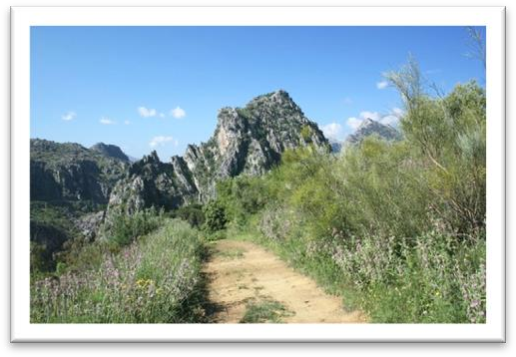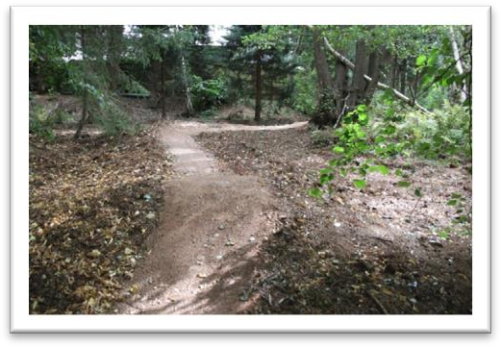track n. a narrow path or road with a rough uneven surface, esp. one made by vehicles, people or animals

scoop n. a tool with a deep bowl-shaped end which is used to dig out and move a soft or powdery substance

a measuring scoop an ice-cream scoop

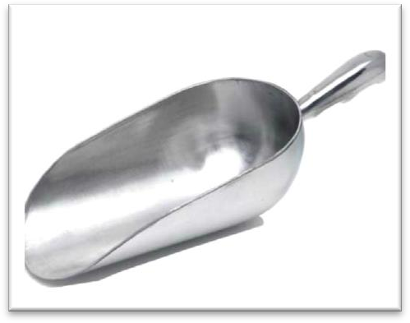 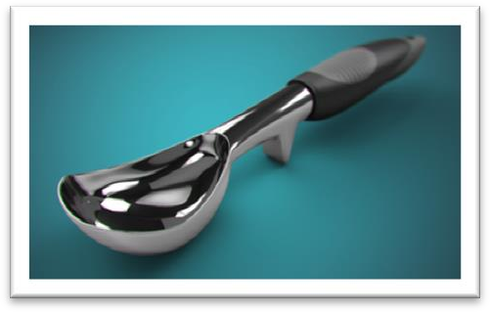

a scoop of ice-cream scoop (up / out) sth.

He scooped water from the stream and splashed it on his face. She bent down and scooped up the little dog.

Carefully scoop out the pulp with a small spoon. hammer / thunder

He hammered / thundered at the door.

It immediately ran away when she saw it, and experts confirmed that a puma will not attack a human being unless it is cornered.

He elbowed his way through the crowd. I am fogged by the issue.

The lady housed the homeless.

We felt sure that *sooner or later* a stone would rip a hole in our petrol tank or damage the engine.

sooner or later 迟早，早晚有一天

You should tell her, because she'll find out sooner or later. rip / tear a hole

*Because of this*, we kept looking back, wondering if we were leaving a trail of oil and petrol behind us.

leave a trail of … behind …

The hurricane left a trail of destruction behind it. The bus left a trail of black smoke behind it.

He left a trail of muddy footprints behind him.

Wherever it went, it left *behind it* a trail of dead deer and small animals like rabbits.

What a relief it was when the boulders suddenly disappeared, *giving way to a stretch of plain where the only obstacles were clumps of bushes*.

relief n. 宽慰，痛苦的缓解或解脱

find a temporary relief permanent relief

to my great relief

give immediate relief from pain

give way to sth. 1. 被（更新更好的事物）代替

Steam trains gave way to electric trains.

Winter gave way to spring.

The storm gave way to bright sunshine. give way to sb. / sth. 2. 让路，向……屈服Drivers must give way to cyclists.

Give way to traffic coming from the right. We must not give way to their demands.

stretch n. an area of land or water, esp. one that is long and narrow （狭长的）一片或一段地或水域

stretch of …

a stretch of plain

a narrow stretch of water

a beautiful stretch of countryside

a particularly dangerous stretch of road

clump n. a group of trees, bushes, or other plants growing very close together 丛

a clump of trees / bushes / flowers / grass worse n. [U] something worse

I'm afraid there is worse to come.

We thought the situation was bad, but worse was to follow.

"What about the bride's dress ― wasn't it appalling?" "I don't know, I've seen worse." fissure n. long deep crack in rock or in the earth （岩石中或土地中的）深长裂缝 in response to …

The president stepped down in response to public pressure.

Oddly shaped forms that are suspended from the ceiling and move in response to a gust of wind are quite familiar to everybody.

renewed adj. happening again with increased interest or strength [only before noun] 更强烈的……

get out

get out of a car / taxi get in

get into a car / taxi get on

get on a bus / train / ship / plane get off

get off a bus / train / ship / plane extend v.（时间或空间）延伸

The Sahara Desert extends *for* miles.

The show has been extended *for* another six weeks. My garden extends *as far as* the river.

The driveway extends *from* the house *to* the high way. An industrial zone extends *along* the river.

Bruce went into a low gear and drove at a terrifying speed, keeping the front wheels astride the crack *as he followed its zigzag course*.

automatic gear

manual gear

an automatic gearbox

a four-speed manual gearbox

Andy drove cautiously along in third gear.

Helen changed gear / gears as she approached the intersection. go / move / shift into … gear

I went / moved / shifted into fourth gear when I got onto the highway. put / slam / slip sth. into … gear

I put / slammed / slipped the car into fourth gear when I got onto the highway.

speed 做不可数名词时，与 at, with 搭配均可

e.g. at / with great speed

speed 做可数名词时，只能与 at 搭配

e.g. at a speed of 60 mph

astride prep. with one leg on each side of sth. 跨在……上

a photograph of my mother sitting astride a horse She sat proudly astride her new motorbike.

The town lies astride a river.

zigzag adj. a pattern that looks like a line of z's joined together a zigzag path along the cliff

Before we had time to worry about what might happen, we were back on the plain again. Bruce consulted the map once more and told us that the village was now only 15 miles away. a nice *cup* of tea

a beautiful *stretch* of field a stagnant *pool* of water

For most of them, 50 pence is a small price to pay for a nice big *bar* of chocolate. charge at … 朝……猛冲

Suddenly the bear charged at us.

He charged at me with his fists flying. come to a stop / halt / standstill

It came to a stop outside the jeweler’s. grind come to a grinding halt come to an end / a close

come to a decision / conclusion / agreement

A yellow light *on the dashboard* flashed angrily and Bruce cheerfully announced *that there was no oil in the engine*!

flash angrily

Sparks were emitted from small black boxes and red lamps flashed on and off angrily.